Garbage and Household Waste Collection
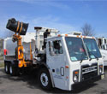
Trash and household waste are collected in 95-gallon containers. The containers may be purchased from the Waste Management divison by calling 385-4650 to schedule delivery.
Please help us to provide efficient service for you by following these guidelines:
- Have con​tainers and/or items for pickup at the street between 5:00 p.m. the day prior to your day of collection and 7:00 a.m. the day of collection.
- Keep at least 3 feet of clearance between your container and any other item (yard waste bags, limbs, bulky items, mailboxes, cable boxes, or vehicles) including the blue recycle container.
- Cans that are overflowing will not be collected. The lid should be able to close securely
- Remove containers from public view at the end of collection day.
- Clearly label your container with your address and record your container serial number.
- Loose trash in can should be bagged, to reduce litter.
- No other garbage will be collected outside of the black can except for yard waste.
- To report service problems, please call 385-4650 on your collection day or by
noon the following business day.
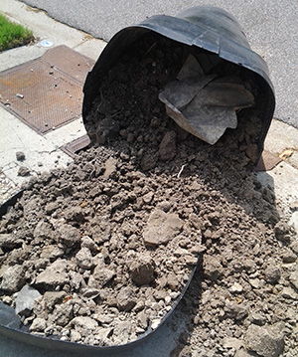
​​Please do not put the following items ​in your black cart:​
- ​​​Remodeling and building materials, carpet, doors, cabinets, toilets, sinks, rocks, dirt, concrete, vehicle parts, tires, paint cans, glass, propane tanks, hazardous materials
- Please do not dispose of dirt or concrete in your black trash can. They weigh the can down, which increase collection and disposal costs. If you don't have a place to use these in your yard, they can be taken to the Virginia Beach Landfill and Resource Recovery Center, where dirt will be used for daily cover and concrete will be crushed into stone for roadbeds, thus reducing operating costs.​

Garbage Can Fee and Warranty
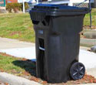
- ​Black refuse containers (95 gallons) may be purchased from the Waste Management divisio​n for $75.00 each.
- You may call us at 385-4650 to schedule free delivery or to discuss questions regarding older cans.
- Blue recycling carts are also available for free.
- Payment must be made by credit card or check or money order made payable to the City Treasurer. We are unable to accept cash payments.
- Refuse containers come with a 10 year warranty. If during that 10 year time frame the container is damaged, we will repair it free of charge. The warranty does not cover fire damage or theft.

Landstown​ Transfer Station
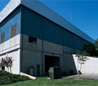
Monday - Friday: 8 a.m. - 5 p.m.
Saturday: 8 a.m. - Noon​
(757) 961-3986
www.SPSA.com

